**BobbinDisk1 Assembly**

**Parts Required**

* 1 x 3D printed bobbinDisk1a.stl
* 1 x 3D printed bobbinDisk1b.stl (* supports required)
* 1 x R6-2RS bearings

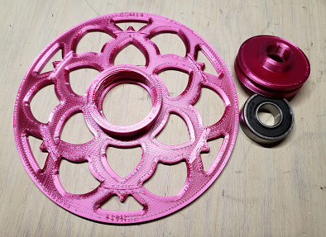

**3D printing notes**

* Printer: Creality CR 10
* Filament: PLA
* Slicer: Ultimaker Cura 4.9.0
* Layer height: 0.2mm
* Infill Density: 25%
* When Supports were enabled for printing bobbinDIsk1b.stil, Support Placement was set to Touching Buildplate to prevent supports being placed in the pulley for the tension string.

**Tools recommended**

* Exacto blade or some other type of small sharp knife
* Wet sandpaper
* Super Glue (cyanoacrylate)
* Gloves (vinyl, nitrile, etc)

**Assembly**

* Remove the supports from under bobbinDisk1b.stl, and ensure there are no snags in the pulley for the tension sting.
* Insert the bearing into bobbinDisk1b.stl. Lay bobbinDisk1b on a surface, and press the bearing into the hole.

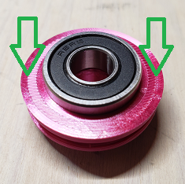

Once it is started, you can flip the piece over and press firmly down on bobbinDisk1b to get the bearing seated as far as it will go. Be careful not to damage any of the printed parts.

* Press bobbinDisk1a.stl on to the other side of the bearing. The threaded side of bobbinDisk1a should face away from the bearing.

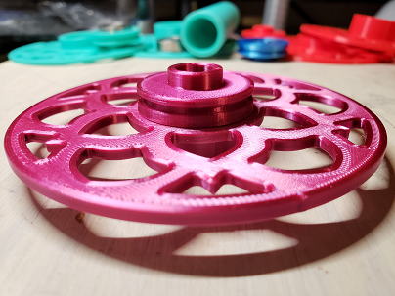

* The bearing may fit snug enough to hold the printed parts together, but it is best to glue the printed parts together especially if the bobbin is going to be sold. An adhesive similar to Super Glue (cyanoacrylate) is recommended, rather than something like hot glue which is too thick. It is important to press the printed parts together firmly, and ensure there are no gaps. If the parts are not lined up properly, the bobbin may wobbly when in use on the spinner. Gloves are suggested so that you can press firmly on the parts without having to be concerned about getting the adhesive on your fingers. Read the warnings on the packaging for the adhesive.

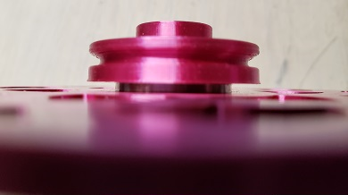

If you leave a small gap between the two printed pieces, you can brush some adhesive in between the parts before quickly pressing them together. Be aware that Super Glue can cure in as little as 5 seconds.

**Fully assembled bobbin**

